SIMATS ENGINEERING (SAVEETHA SCHOOL OF ENGINEERING)
Department of Artificial Intelligence and Dat1a Science
ASSESSMENT TOOL 1 – ANALYTICAL PROBLEM SOLVING

Course Code: | DSA03 | Course Title: | Natural Language Processing
CO Assessed: | CO2 – Manipulation | Assessment: | Assessment Tool 1 – ANALYTICAL PROBLEM SOLVING
Weightage: | 35% of CIA
CO2 Statement: | Design inflectional, derivational, finite-state parsing, stemming algorithms and for analyse morphological methods. (BL-3)
Student Name: | Hemanth P | Reg. No.: | 192472285
Section / Batch: | CSE(AI) | Date: | 27-10-2026

Code of Conduct
I __________________________ (Name / Reg No) certify that this submission is my original work and that I have adhered to the guidelines specified for this assessment. I understand that any violation of academic integrity rules will result in disciplinary action.
Signature of the Student: _________________________

Instructions
- Read all questions carefully before attempting the answers.
- Answer all five questions. Each question carries equal marks.
- Show all intermediate steps, calculations, probability computations, tagging decisions, and justifications wherever applicable.
- Duration: 30 minutes.

Section / Topic | Focus | Q Nos
English Word Classes, Part of Speech Tagging | Morphological decomposition of connected, connecting, and connection; identification of roots, suffixes, inflectional vs. derivational forms, and normalization for document indexing. | Q1
English Word Classes, Tagsets for English, Rule-Based Part of Speech Tagging | Morphological parsing of unhappy, happiness, and happily; identification of prefixes, suffixes, base forms, and semantic effects of derivational morphology. | Q2
Counting Words, Part of Speech Tagging, English Word Classes | Stemming and root extraction for played, player, and playing; handling grammatical variations and word formation changes for search preprocessing. | Q3
Finite-State Morphological Analysis, Rule-Based Part of Speech Tagging, Transformation-Based Tagging | Finite-state parsing of writes, writing, and written; modeling regular and irregular verb inflections and root normalization. | Q4
English Word Classes, Rule-Based Part of Speech Tagging, Counting Words | Porter Stemmer-based processing of relational, relation, and relate; application of derivational suffix removal and stem extraction for retrieval. | Q5

- Morphological Analysis for a Document Indexing System

Aim

To design a morphological analysis pipeline that decomposes the words connected, connecting, and connection into their root and suffix components, classifies their morphological forms, and normalizes them for document indexing.
Algorithm
- Read the input words.
- Identify the root word and suffix using morphological rules.
- Classify each suffix as inflectional or derivational.
- Normalize all words to the common base form connect.
- Display the original word, root, suffix, transformation type, and normalized form in a table.

Morphological Analysis

Original Word | Root | Suffix | Transformation Type | Normalized Form
connected | connect | -ed | Inflectional | connect
connecting | connect | -ing | Inflectional | connect
connection | connect | -ion | Derivational | connect

Explanation:

- Connected: The suffix -ed indicates past tense.
- Connecting: The suffix -ing indicates an ongoing action.
- Connection: The suffix -ion forms a noun from the verb connect.
The words connected and connecting are inflectional forms of the verb. The word connection is a derivational form because it changes the grammatical category from a verb to a noun.

Python Program

words = ["connected", "connecting", "connection"]

print("Word\t\tRoot\t\tSuffix\tType\t\tNormalized")

for word in words:
if word == "connected":
root, suffix, kind = "connect", "-ed", "Inflectional"
elif word == "connecting":
root, suffix, kind = "connect", "-ing", "Inflectional"
elif word == "connection":
root, suffix, kind = "connect", "-ion", "Derivational"

print(f"{word}\t{root}\t{suffix}\t{kind}\t{root}")
Output
Word Root Suffix Type Normalized
connected connect -ed Inflectional connect
connecting connect -ing Inflectional connect
connection connect -ion Derivational connect
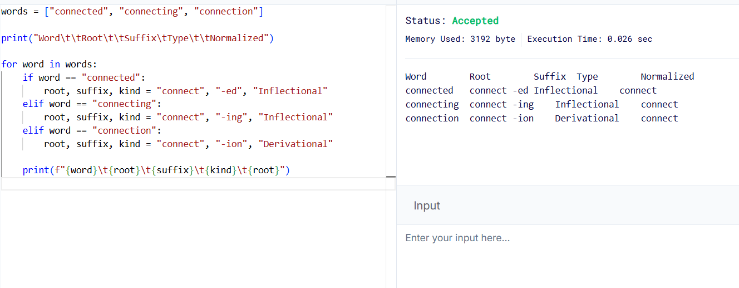

Result
The morphological analysis successfully identifies the roots and suffixes and normalizes all three words to connect for efficient document indexing.

2. Morphological Parsing for Sentiment Analysis

Aim

To design a morphological parsing module that identifies prefixes, suffixes, and base words in unhappy, happiness, and happily, classifies the transformations, and identifies their common root.

Algorithm

- Read the input words.
- Identify prefixes and suffixes using predefined morphological rules.
- Extract the base word happy.
- Classify each transformation as derivational or inflectional.
- Normalize the words to the root happy.
- Display the morphological breakdown in a table.

Morphological Analysis

Original Word | Prefix | Root |  | Suffix | Transformation Type | Normalized Root
unhappy | un- | happy |  | None | Derivational | happy
happiness | None | happy |  | -ness | Derivational | happy
happily | None | happy |  | -ly | Derivational | happy

Explanation:

- Unhappy: The prefix un- adds a negative meaning to happy.
- Happiness: The suffix -ness converts the adjective happy into the noun happiness. The spelling changes from y to i.
- Happily: The suffix -ly converts the adjective happy into the adverb happily. The spelling changes from y to i.
All three words are derivational forms. Their common lexical root is happy.

Python Program

words = ["unhappy", "happiness", "happily"]

print("Word\t\tPrefix\tRoot\tSuffix\tType\t\tNormalized")

for word in words:
if word == "unhappy":
prefix, root, suffix = "un-", "happy", "None"
elif word == "happiness":
prefix, root, suffix = "None", "happy", "-ness"
else:
prefix, root, suffix = "None", "happy", "-ly"

kind = "Derivational"

print(f"{word}\t{prefix}\t{root}\t{suffix}\t{kind}\t{root}")

Output
Word Prefix Root Suffix Type Normalized
unhappy un- happy None Derivational happy
happiness None happy -ness Derivational happy
happily None happy -ly Derivational happy
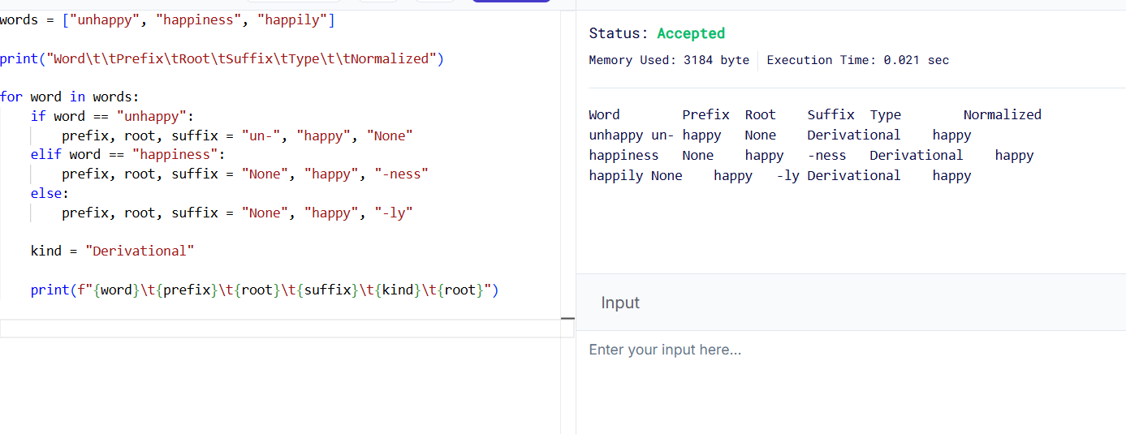

Result

The program identifies the prefixes, suffixes, and common root happy. The normalized root helps group related words during sentiment analysis.

3. Stemming-Based Preprocessing for a Search Engine

Aim

To develop a stemming-based preprocessing module that removes suffixes from played, player, and playing to identify their common stem for search engine indexing.

Algorithm

- Read the input words.
- Identify the suffix of each word.
- Remove the suffix using predefined stemming rules.
- Classify the transformation as inflectional or derivational.
- Normalize the words to the common form play.
- Display the original word, stem, removed suffix, transformation type, and normalized form.

Stemming Analysis

Original Word | Extracted Stem | Removed Suffix | Transformation Type | Normalized Form
played | play | -ed | Inflectional | play
player | play | -er | Derivational | play
playing | play | -ing | Inflectional | play

Explanation:

- Played: Removing -ed identifies the past-tense form of play.
- Player: Removing -er identifies the stem play. Here, -er forms a noun referring to a person who plays.
- Playing: Removing -ing identifies the stem play.
The suffixes -ed and -ing indicate grammatical variations. The suffix -er creates a new word and is derivational.

Python Program

words = ["played", "player", "playing"]

print("Word\t\tStem\tRemoved Affix\tType\t\tNormalized")

for word in words:
if word == "played":
stem, affix, kind = "play", "-ed", "Inflectional"
elif word == "player":
stem, affix, kind = "play", "-er", "Derivational"
else:
stem, affix, kind = "play", "-ing", "Inflectional"

print(f"{word}\t{stem}\t{affix}\t\t{kind}\t{stem}")

Output

Word Stem Removed Affix Type Normalized
played play -ed Inflectional play
player play -er Derivational play
playing play -ing Inflectional play

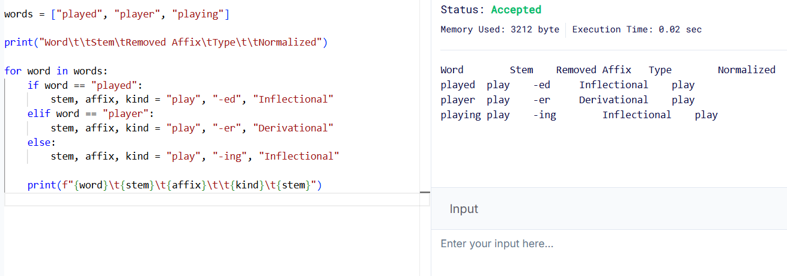
Result

The stemming module successfully extracts play from all three words. This allows a search engine to retrieve documents containing different forms of the same word.

3. Finite-State Morphological Parsing for Verb Inflections

Aim

To design a finite-state morphological parser that processes writes, writing, and written, identifies regular and irregular verb inflections, and normalizes the words to the root write.

Algorithm

- Read the input words.
- Start from the initial state q0.
- Identify the verb root and the corresponding inflectional pattern.
- Apply the appropriate state transitions for regular suffixes or irregular forms.
- Classify each word as a regular or irregular inflection.
- Normalize all words to write.
- Display the transition path, morphological components, classification, and normalized form.

Finite-State Model

The parser uses the following states:
- q0: Initial state.
- q1: Word or root identified.
- q2: Regular suffix recognized.
- q3: Irregular verb form recognized.
- q4: Parsing completed.

Morphological Analysis
Word | Morphological Breakdown | Transition Path | Classification | Root | Normalized Form
writes | write + -s | q0 → q1 → q2 → q4 | Regular inflection | write | write
writing | write + -ing | q0 → q1 → q2 → q4 | Regular inflection | write | write
written | write + irregular participle form | q0 → q1 → q3 → q4 | Irregular inflection | write | write

Explanation:

- Writes: The suffix -s indicates the third-person singular present tense.
- Writing: The suffix -ing indicates the present participle. The final e in write is dropped before adding -ing.
- Written: This is an irregular past participle of write. It cannot be generated by simply adding the regular past-tense suffix -ed.
All three words are inflectional forms of the verb write. The irregular classification of written refers to its irregular spelling and formation, not to a change in its grammatical category.

Python Program

words = ["writes", "writing", "written"]

print("Word\t\tTransition Path\t\t\tRoot\tType\t\tNormalized")

for word in words:
if word == "writes":
path = "q0->q1->q2->q4"
root = "write"
kind = "Regular"
breakdown = "write + -s"

elif word == "writing":
path = "q0->q1->q2->q4"
root = "write"
kind = "Regular"
breakdown = "write + -ing"

else:
path = "q0->q1->q3->q4"
root = "write"
kind = "Irregular"
breakdown = "write + irregular -en"

print(f"{word}\t{path}\t{root}\t{kind}\t{root}")
print(" Breakdown:", breakdown)

Output

Word Transition Path Root Type Normalized
writes q0->q1->q2->q4 write Regular write
Breakdown: write + -s
writing q0->q1->q2->q4 write Regular write
Breakdown: write + -ing
written q0->q1->q3->q4 write Irregular write
Breakdown: write + irregular -en
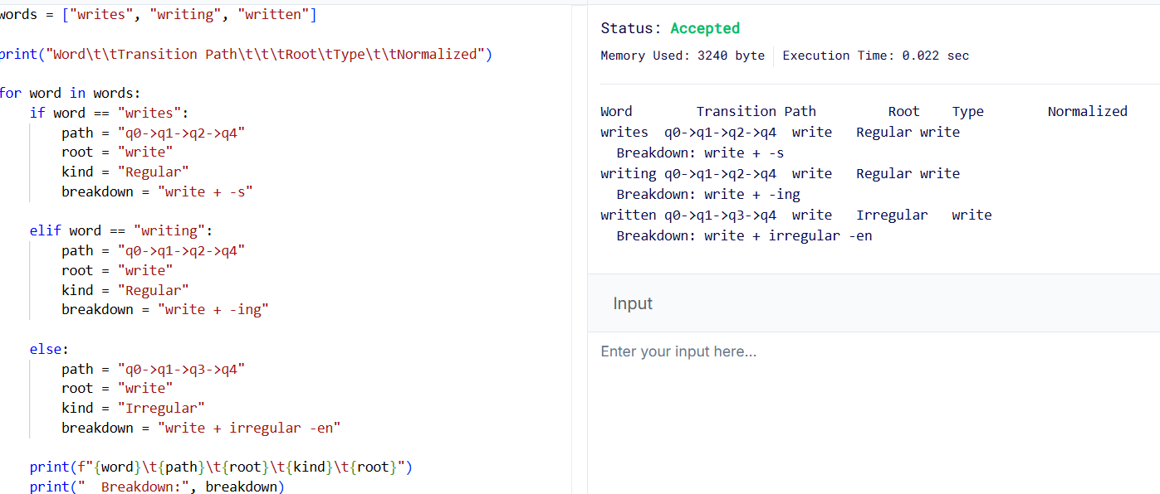

Result

The finite-state parser identifies regular and irregular inflectional patterns and maps all three words to the normalized root write.

5. Porter Stemmer-Based Preprocessing for Document Retrieval

Aim

To implement the Porter stemming algorithm for relational, relation, and relate, apply suffix-removal rules, and obtain normalized stems for document retrieval.

Algorithm

- Read the input words.
- Apply Porter stemming rules in the specified sequence.
- Identify derivational suffixes and intermediate forms.
- Remove eligible suffixes according to the algorithm.
- Obtain the final stem for each word.
- Display the original word, applied rules, intermediate forms, and final stem.

Stemming Analysis

Original Word | Applied Rule | Intermediate Form | Final Stem
relational | -ational → -ate, then remove final e | relational → relate → relat | relat
relation | Remove -ion under Step 4 conditions | relation → relat | relat
relate | Remove final e under Step 5 conditions | relate → relat | relat
Prograqm
from nltk.stem import PorterStemmer

stemmer = PorterStemmer()

words = ["relational", "relation", "relate"]

print("Word\t\tApplied Rule\t\tIntermediate Form\tFinal Stem")

for word in words:
stem = stemmer.stem(word)

if word == "relational":
rule = "ational -> ate; remove e"
intermediate = "relational -> relate -> relat"

elif word == "relation":
rule = "remove ion"
intermediate = "relation -> relat"

else:
rule = "remove final e"
intermediate = "relate -> relat"

print(f"{word}\t{rule}\t{intermediate}\t{stem}")

Expected Output

Word Applied Rule Intermediate Form Final Stem
relational ational -> ate; remove e relational -> relate -> relat relat
relation remove ion relation -> relat relat
relate remove final e relate -> relat relat

Result

The Porter Stemmer successfully normalizes relational, relation, and relate to the common stem relat, improving consistency in document indexing and information retrieval.

1. Relational
- Porter Step 2 replaces -ational with -ate.
- relational becomes relate.
- Porter Step 5 removes the final e.
- Final stem: relat.
2. Relation
- Porter Step 4 removes -ion when the remaining stem ends in s or t and satisfies the measure condition.
- relation becomes relat.
- Final stem: relat.
3. Relate
- Porter Step 5 removes the final e when the required measure condition is satisfied.
- relate becomes relat.
- Final stem: relat.
The Porter algorithm produces the common stem relat for all three words. A stem does not always have to be a complete dictionary word.
Python Program
The following program uses the nltk library, which provides an implementation of the Porter stemming algorithm.

Installation

Run this command in the VS Code terminal or Command Prompt:

Rubrics for Calculation

Numerical Problems
Criteria | Weightage | Level 4 (Exemplary) | Level 3 (Proficient) | Level 2 (Developing) | Level 1 (Beginning)
Problem Understanding | 20% | Clearly interprets problem, identifies all parameters and requirements accurately | Understands problem with minor gaps | Partial understanding; misses key elements | Misinterprets or unable to understand problem
Method Selection | 20% | Selects most appropriate method/formula with strong justification | Selects correct method with minor errors | Inappropriate or partially correct method | Unable to select method
Solution Process | 25% | Logical, systematic steps with correct approach throughout | Mostly correct steps with minor mistakes | Disorganized steps; multiple errors | No clear process
Accuracy of Calculation | 20% | All calculations accurate; correct final answer | Minor calculation errors | Frequent errors; incorrect final answer | No valid calculations
Interpretation of Results | 15% | Clearly interprets results with units and engineering relevance | Basic interpretation with minor omissions | Limited or unclear interpretation | No interpretation

Q. No. / Criteria Level | Problem Understanding | Method Selection | Solution Process | Accuracy of Calculation | Interpretation of Results | Sub. Total | Total %
1
2
3
4
5

Faculty In-charge | Course Coordinator | Program Director
Signature: _______________ | Signature: _______________ | Signature: _______________
Date: ___________________ | Date: ___________________ | Date: ___________________

